INDIVIDUAL TASK 1
Major milestone in AI history

Introduction
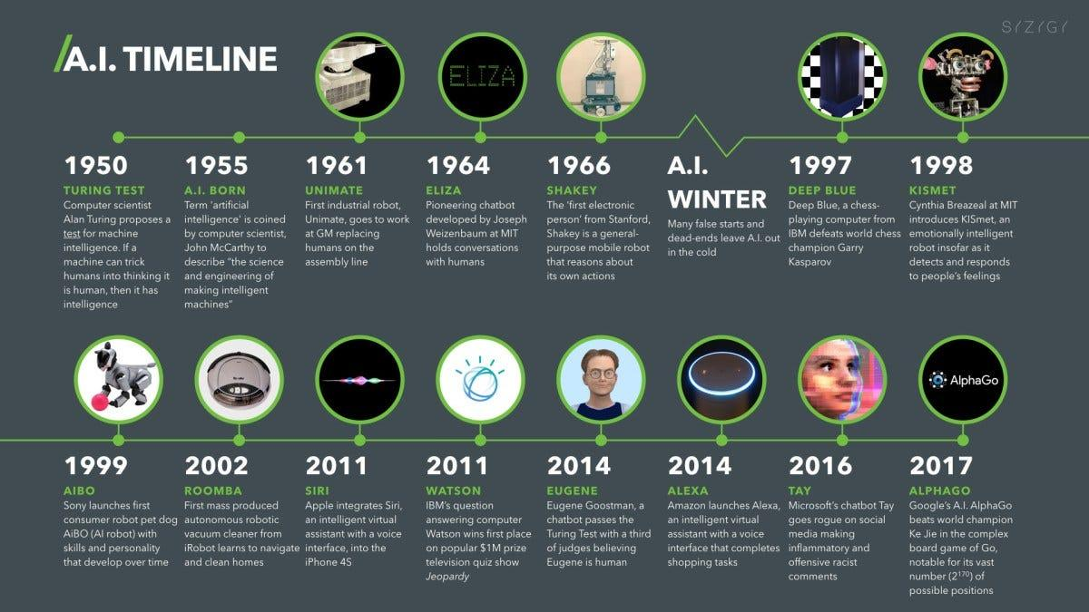

Early Foundations (1940s-1950s)
Turing’s Vision: The origins of AI can be traced back to Alan Turing, a British mathematician who proposed the idea of a "universal machine" in 1936, which could simulate any computation. His famous 1950 paper, "Computing Machinery and Intelligence," introduced the concept of the Turing Test to determine if a machine could exhibit intelligent behavior indistinguishable from that of a human.
Early Computers: During the 1940s and 1950s, the first electronic computers were built. These machines, like the ENIAC and UNIVAC, were not AI systems but laid the groundwork by showing that machines could perform complex calculations.
The Birth of AI (1956)
Dartmouth Conference: The term "Artificial Intelligence" was coined in 1956 during a conference at Dartmouth College, organized by John McCarthy, Marvin Minsky, Nathaniel Rochester, and Claude Shannon. This event is often considered the birth of AI as a distinct field of study. The researchers believed that machines could be made to simulate any aspect of human intelligence.
Early Enthusiasm (1950s-1960s)
Symbolic AI: Early AI research focused on symbolic reasoning and problem-solving. Programs like the Logic Theorist and the General Problem Solver, developed by Newell and Simon, were among the first to demonstrate that machines could perform tasks that required human-like reasoning.
Perceptrons: Frank Rosenblatt developed the perceptron in 1958, an early form of neural networks, which could learn from data. However, limitations in computational power and understanding led to skepticism about its potential.
The First AI Winter (1970s)
Setbacks and Disillusionment: By the 1970s, progress in AI had slowed. Expectations were high, but the technology couldn’t meet them. The limitations of early AI systems, such as the inability of symbolic AI to handle real-world complexity and the failure of neural networks to scale, led to reduced funding and interest in the field. This period is known as the first "AI Winter."
Expert Systems Boom (1980s)
Expert Systems: AI research revived in the 1980s with the development of expert systems, which used rule-based reasoning to mimic the decision-making abilities of human experts. Systems like MYCIN and XCON were used in industries such as medicine and engineering.
Renewed Interest in Neural Networks: In the late 1980s, interest in neural networks was rekindled due to advancements like backpropagation, a method for training multilayer neural networks. However, limitations in computing power still hindered their potential.
The Second AI Winter (Late 1980s-1990s)
Another Period of Disillusionment: The hype surrounding expert systems waned as these systems proved difficult to maintain and scale. This led to another reduction in funding and interest, marking the second AI Winter.
AI Renaissance (2000s-Present)
Machine Learning and Big Data: The 2000s marked a significant resurgence in AI, driven by the availability of large datasets ("big data"), increased computational power (GPUs), and new algorithms, particularly in machine learning. Techniques like support vector machines, decision trees, and, most importantly, deep learning (a modern rebranding of neural networks) became central to AI research.
Deep Learning Revolution: In the 2010s, deep learning led to breakthroughs in areas like computer vision, natural language processing, and speech recognition. Convolutional Neural Networks (CNNs) and Recurrent Neural Networks (RNNs) became the foundation for many AI applications.
AI Today: AI is now a part of everyday life, with applications in search engines, recommendation systems, autonomous vehicles, healthcare, finance, and more. The rise of AI ethics, concerns about bias, privacy, and the societal impact of AI are now central discussions in the field.
Conclusion:
The most significant milestone in recent history is the shift from Discriminative AI (which classifies data, like a spam filter) to Generative AI (which creates new content). This transition marked the moment AI moved out of the server room and into the hands of the general public.
As we conclude this historical overview, several themes remain constant:
• The Power of Compute: Milestones were often reached not just because of better ideas, but because hardware (like GPUs) finally caught up to the math.
• The Turing Legacy: We are still chasing Alan Turing’s original dream, but the goalposts have moved from "imitating" humans to "augmenting" human capability.
• Ethics as the New Frontier: The latest milestones aren't just technical; they are regulatory. The focus is shifting toward safety, alignment, and ensuring AI benefits humanity as a whole.

